# ARINC 429 CD Changelog

## 2016/10/17

Upgraded to LV 2015SP1 and NIVS 2015 SP1; Cutom Device based on AIT 5.8.1 driver;

## 2016/04/26

AIT and SEA version upgraded to LV 2015 and NIVS 2015

## Dev after 19bca0e

* All development done in LV 2012
* Added Pharlap + VxWorks targets (each including conditional symbol „SEA_FPGA == TRUE“)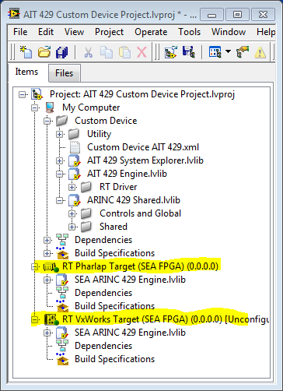
* Mass compiled
* Introduced conditional disable symbol “Debug == FALSE” on project level to easily turn debugging console outputs off and on later on
* Created additional XML so user can choose between AIT and SEA version
  + Version 3.0.0.
  + Pharlap and VxWorks Target
* Commented out all AIT driver code using the conditional disable symbol on Pharlap and VxWorks
* Built and deployed on 9082 – no errors